
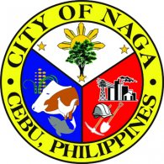
Republic of the Philippines
Province of @prov
@lgutype of @mun
@UTYPE HEALTH OFFICE
HEALTH CERTIFICATE
TO WHOM IT MAY CONCERN:
This is to certify that Mr./Mrs./Ms. @applicant, @age years old, has been examined in this office and was found as of this date to be free from any communicable diseases.
Issued this @day day of @month @year, at Rural Health Unit of @mun, @prov.
Type of Work: |  |  | @occupation
Kind of Business: |  |  |  |  | @kindbus
Name of Establishment: |  |  |  |  |  |  | @establishment
Business Address: |  |  |  |  |  | @busaddress
Immunization: |  |  |  | @immunization
Remarks: |  | @remarks
O.R. No.: | @orno
Issued At: | @isat
 |  |  |  |  |  |  |  |  | @head
 |  |  |  |  |  |  |  |  | @ltype Health Officer

